The target website: https://www.timesjobs.com/

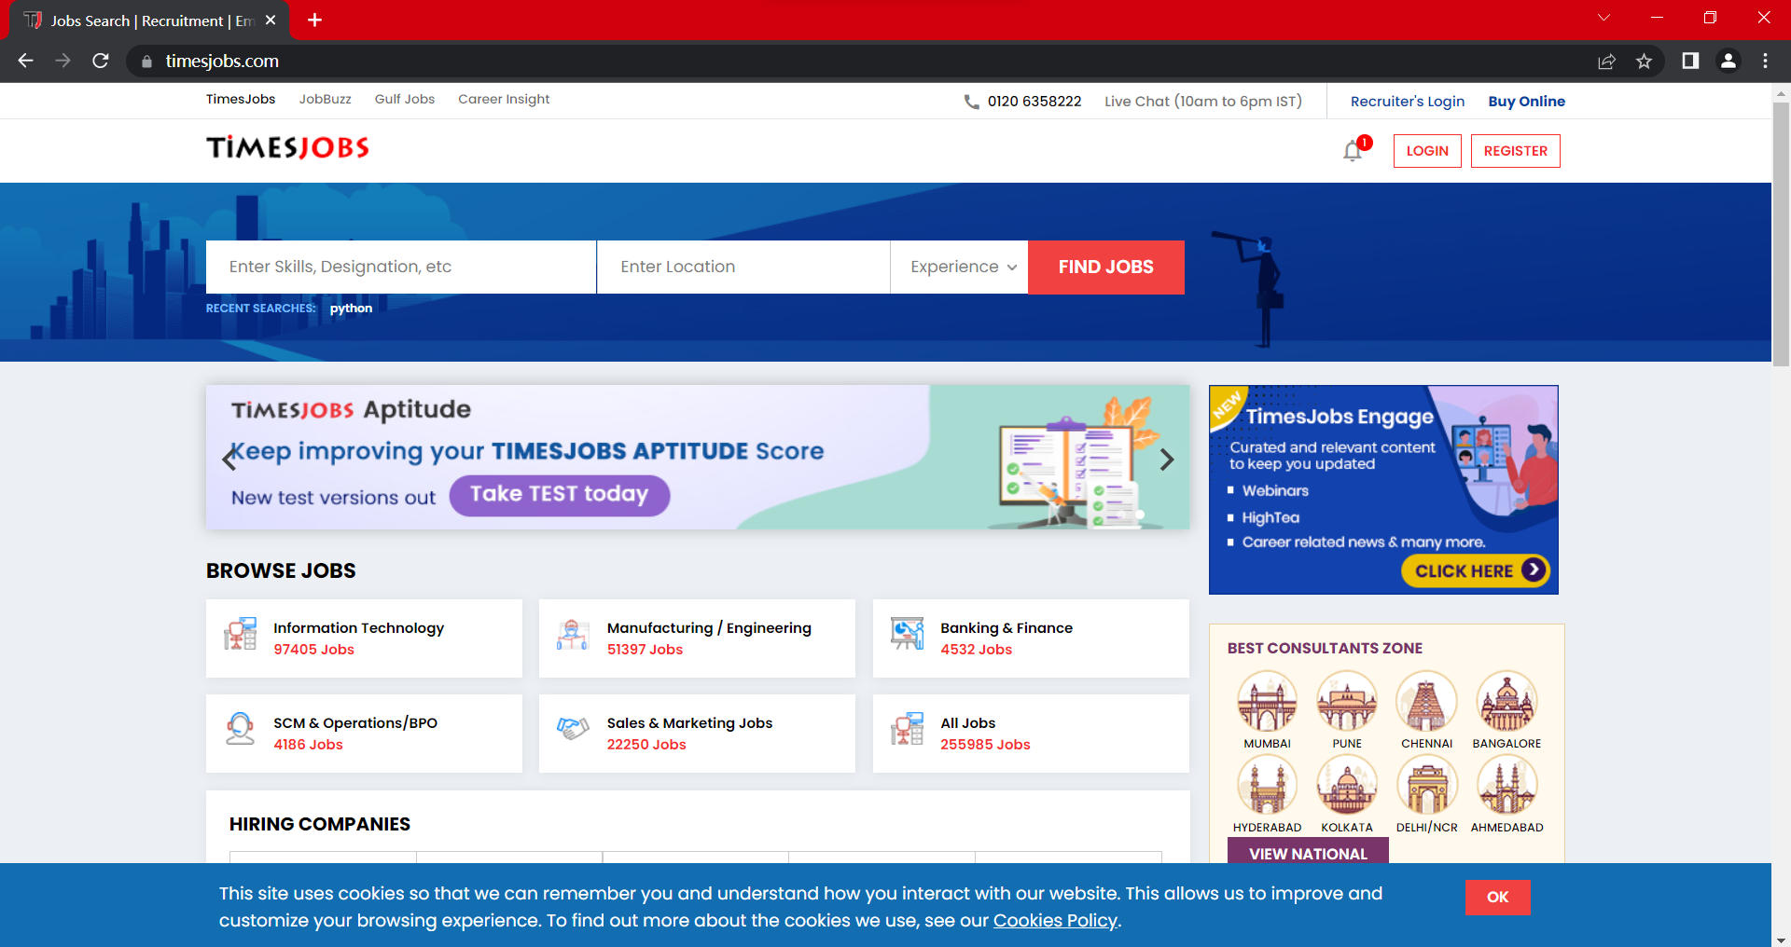

The target webpages (search python, java, php):

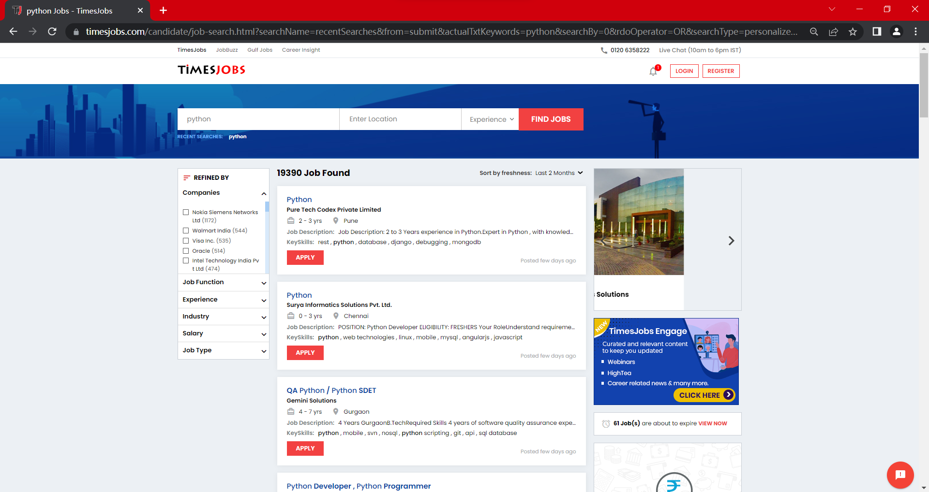

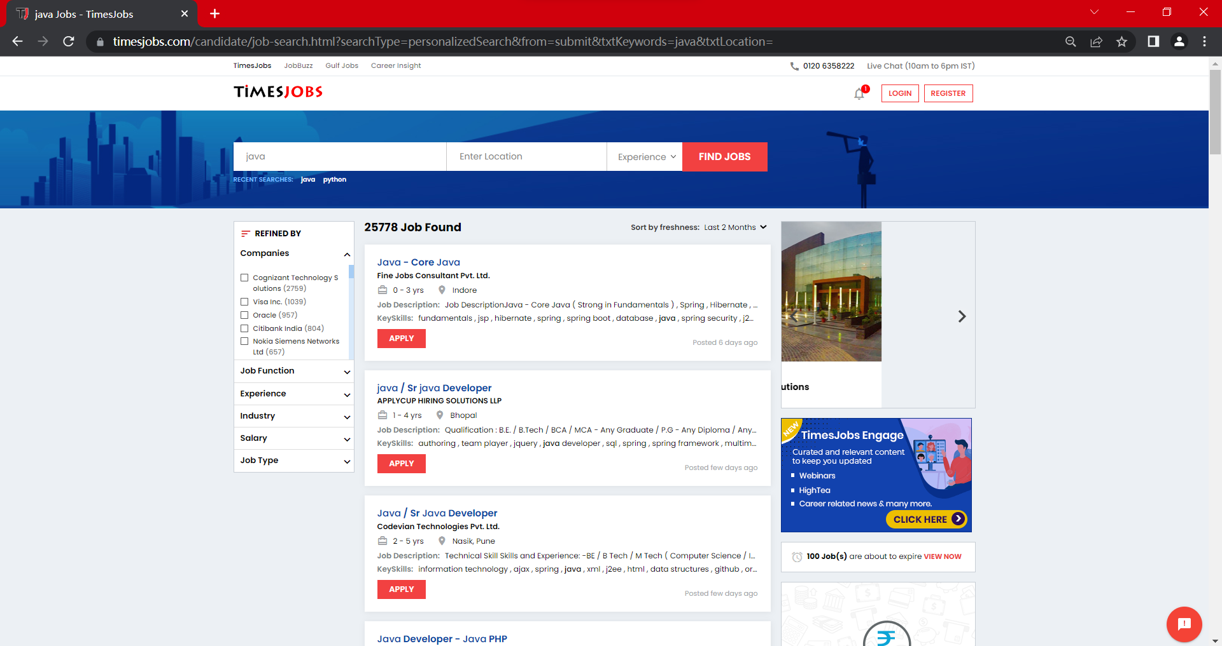

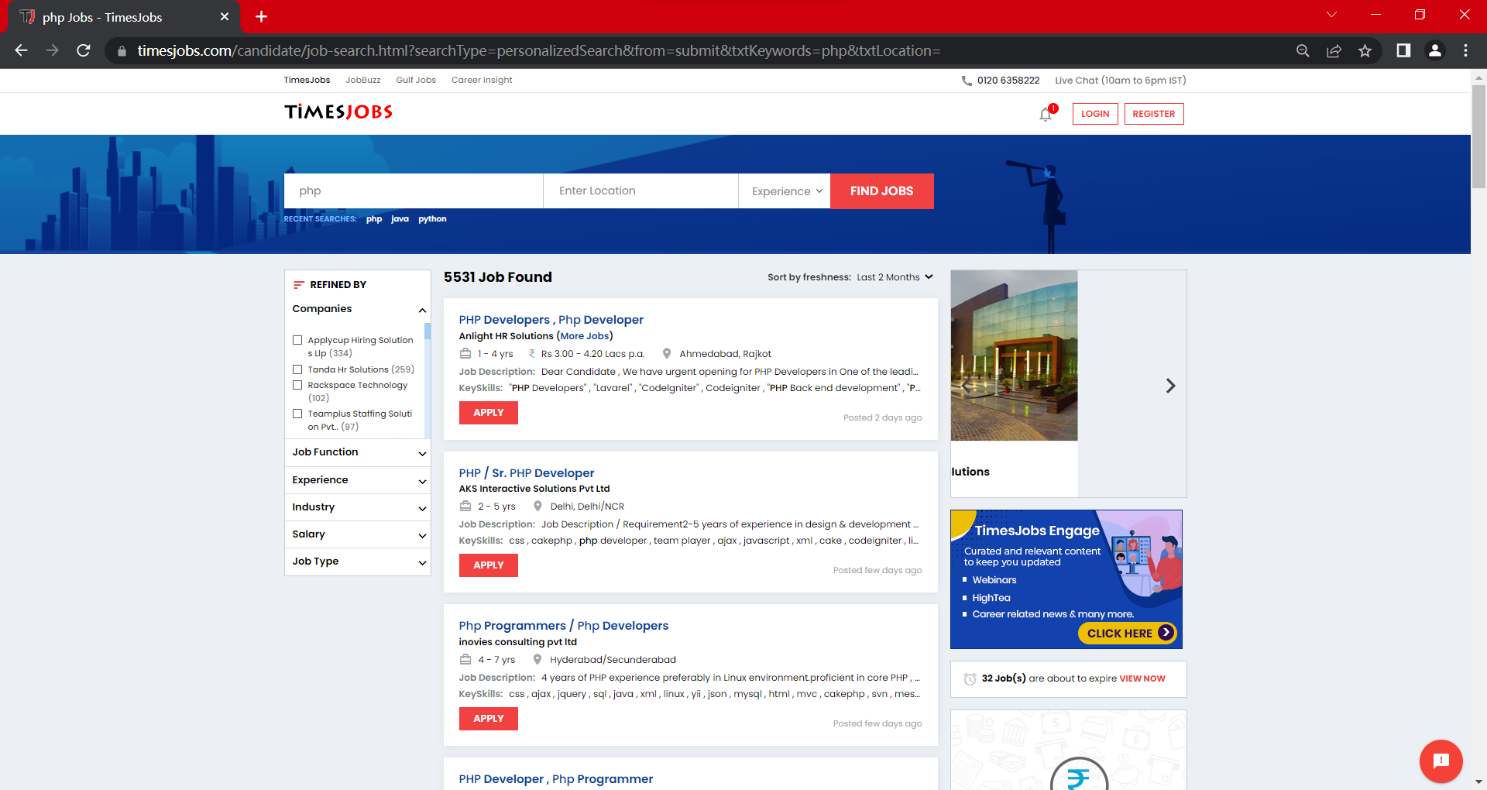

Python Code:

''' This program will perform a web scrape on TIMESJOBS web pages and extract the following Job information:

job name, company, location, job description, skills, more information (the address of the job web page)'''

*from* bs4 *import* BeautifulSoup

*import* urllib.request

*import* datetime

*# A Job class is created in order to create an object for each job instance and save the information as its attributes.*

class Job:

    def __init__(*self*,*name*, *company*, *location*, *job_des*, *skills*, *more_info*):

*self*.name = *name*

*self*.company = *company*

*self*.location = *location*

*self*.job_des = *job_des*

*self*.skills = *skills*

*self*.more_info = *more_info*

*# This function creates a string include each job's attributes.*

    def get_string(*self*):

*return* "Job name: " + str(*self*.name) + "\nCompany: " + str(*self*.company) + "\nLocation: " + str(*self*.location) \

            + "\nJob description: " + str(*self*.job_des) + "\nRequired skills: " + str(*self*.skills) + "\nMore Info: " + *self*.more_info + "\n\n" + "*" * 80 + "\n"

*# This function performs the scrape of TIMESJOB pages. It collets all jobs' information blocks in a page.*

*# It takes one argument: job_type. The job_type means the type of job, such as java, php, and python here.*

def req_data(*job_type*):

    job_info = []

*try*:

        source = urllib.request.urlopen(f"https://www.timesjobs.com/candidate/job-search.html?searchType=personalizedSearch&from=submit&txtKeywords={*job_type*}&txtLocation=")

        tag = BeautifulSoup(source.read(), "html.parser")

        print(f"Requiring {*job_type*} jobs, please wait a moment...")

*#This statment finds all blocks that includ job information*

        jobs = tag.find_all('li', *class_* = 'clearfix job-bx wht-shd-bx')

*#This for loop traverse every single job information block*

*for* job *in* jobs:

            job_info.append(Job(*req_individual_data(job)))

*return*(job_info)

*except*:

        print("Your retrieval request was unsuccessful.")

*# This function finds particular information in one block*

*# and assigns each piece of information to a corresponding variable of a job object*

def req_individual_data(*job*):

    job_name = *job*.header.h2.a.text.strip().replace('\r', '')

    company_name = *job*.find('h3', *class_* = 'joblist-comp-name').text.replace('(More Jobs)', '').strip().replace('\r', '')

    location = *job*.find('ul', *class_* = 'top-jd-dtl clearfix').findChild('span').text.strip().replace('\r', '')

    job_des = *job*.find('ul', *class_* = 'list-job-dtl clearfix').findChild('li').text.strip().replace('\r', '').replace('\n', '').replace('Job Description:', '')

    skills = *job*.find('span', *class_* = 'srp-skills').text.strip().replace('  ,  ', ', ')

    address = *job*.header.h2.a['href']

*return*(job_name, company_name, location, job_des, skills, address)

*# This function performs a frequency count of all words in the different {job}info.txt file using the dictionary concept.*

def word_freq(*job_type*):

*try*:

*with* open(f"{*job_type*}info.txt", "r") *as* f:

            content = f.read().split()

            job_dict = {}

*for* word *in* content:

*if* word *in* job_dict:

                    job_dict[word] += 1

*else*:

                    job_dict[word] = 1

            print(f"The frequency of all word occurrences in {*job_type*}info.txt file is:\n", job_dict)

*except*:

        print(f"File {*job_type*}info.txt does not exsit.")

*#This function calls req_individual_data function, and writes the retrieved data into a corresponding txt file*

def get_job_data(*job_type*):

*with* open(f"{*job_type*}info.txt", "w") *as* f:

        f.write('Job Type: ' + *job_type* + "   Time: " + datetime.datetime.strftime(datetime.datetime.now(), '%Y-%m-%D %H:%M:%S') + \

            "\n\n" + "*" * 80 + "\n")

*for* job *in* req_data(*job_type*):

*# Calling get_string method to create strings out of each job's attributes.*

            each_job = job.get_string()

            f.write(each_job)

    print(f"Retrieval {*job_type*} job information complete. You can find the data in {*job_type*}info.txt.")

def main():

*#This list stores the types of job that user wants to retrieve.*

    job_intentions = ['python','java','php']

    print("Retrieving Job information from the TIMESJOBS and saving it in (job_type)info.txt file...")

*#Retrieve each job type in the job_intentions list*

*for* job_type *in* job_intentions:

        get_job_data(job_type)

*#Checking the frequency of words in {job_type}info.txt file*

    word_freq(job_intentions[0]) *#This statement check pythoninfo.txt*

*#word_freq(job_intentions[1]) #This statement check javainfo.txt*

*#word_freq(job_intentions[2]) #This statement check phpinfo.txt*

    print("Retrieval complete. Goodbye.")

*if* __name__ == "__main__":

    main()

Terminal Output:

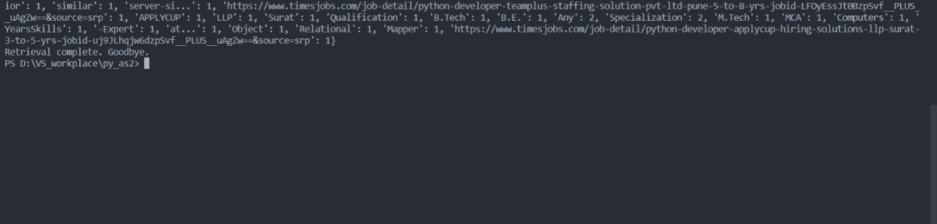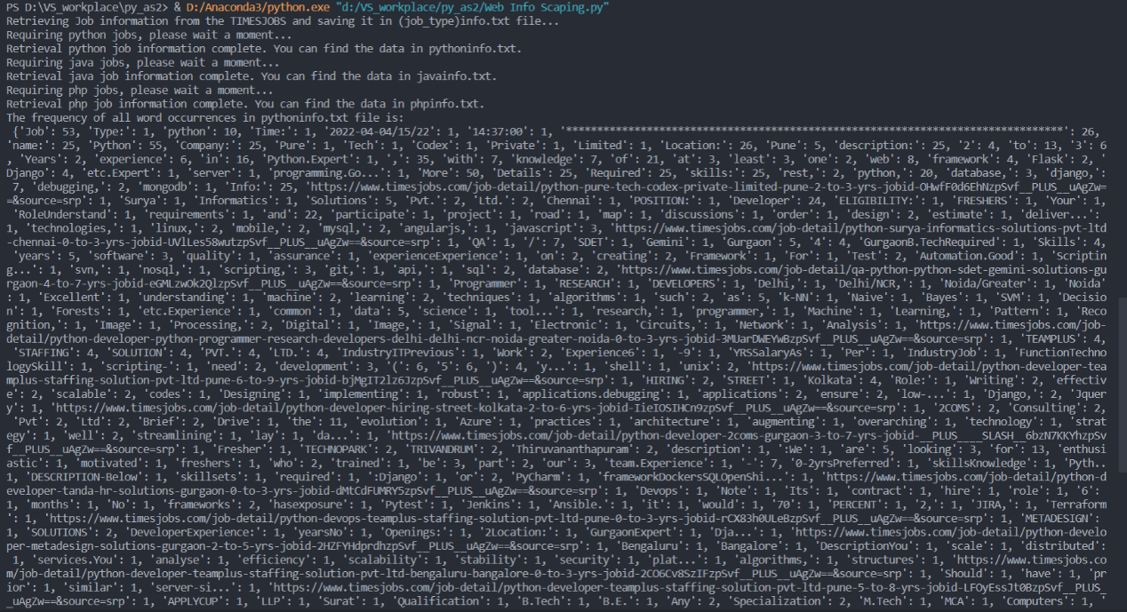

The Result in .txt Files:

